CSCC10: Human-Computer Interaction

Pal-ette

Lara Gomez

Pantysh Ghurburrun

Basmala moumneh

Zhe Cao

Connie Lin

Jeremy Cheng

**Personas, Scenarios, and HTA**

Personas:

Kris is a 21 year old artist. They originally went to college for graphic design but dropped out in their third year because it wasn’t right for them. They now live with their partner in an apartment where they share rent. Kris is fairly active on social media, where they post a mixture of updates about their life, their most recent works, and interact with fans and other artists. They make most of their income through Ko-fi and commissions, with slight supplements from work they have uploaded to print-on-demand services such as Redbubble. They sometimes go to conventions in order to sell physical prints of their art.

Jason is a 15 year old high-school student who lives with his parents. He likes anime and occasionally draws, though it’s typically only in the margins of his notes. His hobbies also include playing video games. He’s relatively average at academics and has no real life goals so far. He likes looking at cool anime-style art and only occasionally posts comic pages he’s drawn for feedback. He has a lot of original characters that he wants to turn into some big project someday, but until then he enjoys requesting that artists draw them.

Steve is a 40 year old professional who works for an animation studio. He lives with his wife. In his free time he likes watching birds. Most of his work is under NDA so he cannot share it online until many years after it has come out (assuming that it comes out at all). He only really posts online as a portfolio or as a quick behind the scenes, but other than that does not use social media. It is important to him that he can organize his work and display it in as high a quality as possible.

Scenarios:

Steve wants to create a post on social media about some work that he has done on a recent animated movie now that his NDA has expired. He uploads a few pages of concept art. The site suggests some automatic thumbnails to him, and he rejects them since they contain spoilers. He chooses a custom thumbnail using the site’s UI. He then titles the work as “Movie concept art” and fills in the caption with what he was aiming for with the project. Finally, he tags the work as *#Concept Art* and *#Painting* so that people looking for these topics can see them.

Jason sees some art that he likes done by Kris. He writes a comment expressing his favorite parts of the piece. Kris replies to his comment thanking him for his kind words.

Kris decides to save some nice art using Pal-ette’s gallery function. Since this is art in a style they haven't seen before, they decided to make a new gallery to save this kind of art. They name the gallery and add the art to the gallery.

Jason wants to commission some art of his favorite characters. He creates a call for commissions. However, he soon sees that Kris has commissions open and cancels his open call. He contacts Kris and asks them to draw his characters, which he provides some references of and inspiration using his gallery pages. He pays them through the website. After a week, he receives his art.

Steve has posted some art that is very striking. Jason and Kris both notice it. Since Jason is also a curator, he nominates the piece for the site’s hall of fame. Kris then votes on the piece, as do other people. After many votes, Steve’s piece is selected to be in the Hall of Fame of the site so that many people can see it. Steve’s piece now also has a badge on it marking it as part of the Hall of Fame.

Creating a post:



Replying to a post:



Creating a gallery and adding art:



Commissioning artists:



Hall of fame:



**Gathering User Requirements**

One of the best ways to understand what users want is to observe their daily feedback on artistic and social platforms. By looking at the communication environment of users, we can better understand the problems they are currently facing and what improvements they need. The advantage of observation is that potential problems can be better identified compared with other methods. Users update their feelings on social platforms, but it is easy to forget them after a while. As a result, it can sometimes be difficult for users to explain their needs for an artistic, social platform. Therefore, be in cases where users provide misleading information or cannot fully remember all of their tasks in the way they use the platform. There are some disadvantages associated as well. It may be difficult to capture enough information in one user's comments. The quality of reviews varies from user to user, so it takes multiple collections of information to meet expectations. An empathy map may help our group align on a deep understanding of target users by visualizing their attitudes and behaviors.

An interview is also an excellent way to get relevant information. Potential problems that users overlook can be discovered through communication. Compared to observation, interviews can obtain more subjective feelings from users by using open-ended questions and requesting further information if necessary. Interviews with individual users require less planning and scheduling than focus groups or workshops. So it is suitable as a technique for collecting user requirements at the current stage. We will try to address some limitations of interviews during the process: Minimize questions that reflect the interviewer's preconceived notions, which can affect responses. We will start with friends around us and set the target users of the interview to people not related to the platform's interests to ensure the results' fairness and accuracy.

**Types of users selected**

The users selected are those interested in art, formal education in the art world and users have used social media to sell artwork. We have selected users who are interested in art as this would predominantly be the users Pal-ette is targeting, it would be very insightful to understand the limitations of other websites, pros and cons, and features they would like to be included. We also selected those with formal education in art fields and those who intend to sell art. This allows us to better understand the technical limitations of creating art, uploading art and finally selling that art work. Overall selecting these users provides crucial knowledge of how systems should look and behave.

We interviewed 3 individuals who have a variety of knowledge and interests in art and 4 who are in the business of producing and selling artworks. We hoped to interview more users, however, time constraints of the interviewees and phase 2 deadlines prevented that.

Other limitations of selecting users were the age demographic and their familiarity with other forms of social media/art websites. It was difficult to interview people who are not within the age ranges of late teens to mid-20s. Age demographic is an important factor to consider as older individuals may have different suggestions or needs. The ages of the interviewers also limited the information to those who tend to be technologically savvy and have prior familiarity with other forms of social media.

**Requirement Gathering Artifacts**

For our user observations, we looked at various social media platforms to observe what users had to say. These platforms include Reddit, DeviantArt, ArtStation, Instagram, Tumblr and Twitter. Observations were then recorded in an empathy map to help illustrate the users’ thought processes as shown below.

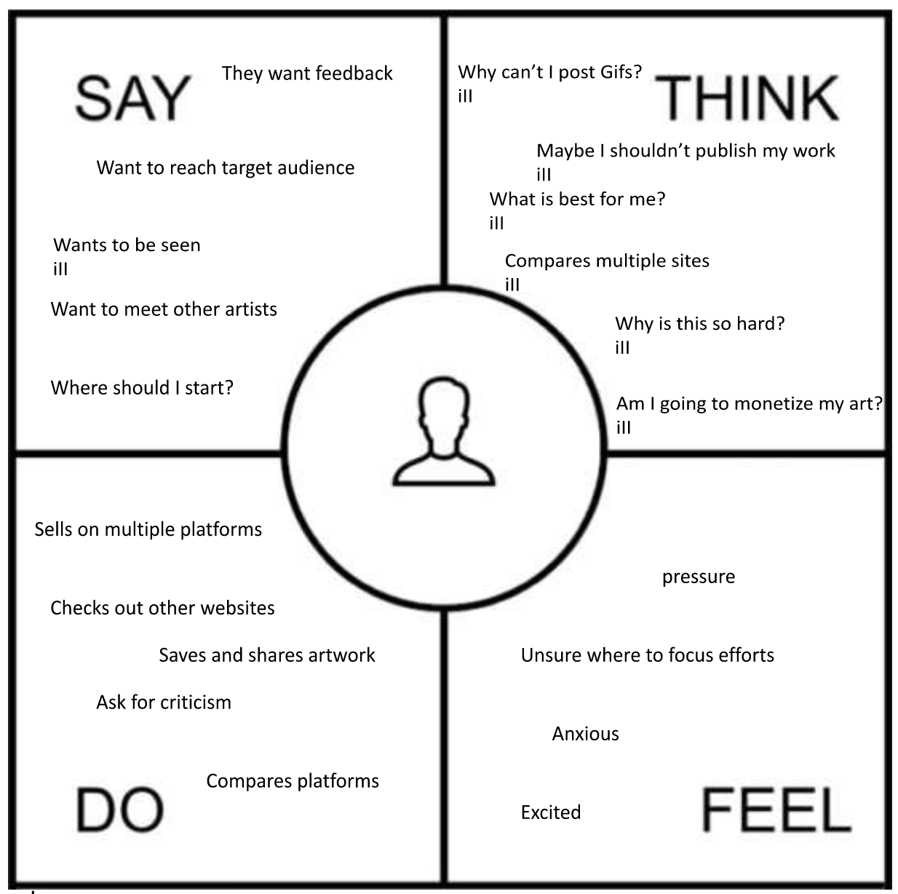

**Who:** Oftentimes people who use art platforms consist of hobbyists and professionals. Some professionals use these platforms to monetize their craft and make a living.

**Where:** The platforms that most artists currently use are DeviantArt, ArtStation, Instagram, Tumblr and Twitter.

**What:** Artists are able to explore different forms and genres of art on these platforms. As well, they are able to post their work for feedback/criticism or to reach their target consumer. These platforms can be used to build a following and increase the credibility of the artist.

Based on others’ conversations about different platforms certain conclusions can be made from these observations.

1. Users have mentioned several times that algorithms on platforms such as Instagram no longer provide artists with a large audience reach. For algorithms to provide an artist with exposure, they must post often to be seen by the algorithm. Moreover, they have mentioned that it is difficult for artists to discover each other.
2. The quality of the posted art differs from platform to platform as some sites require users to resize their images. This can reduce the visual aesthetic of the art, decreasing the valuation of the art.
3. It seems that people like using platforms that allow them to easily organize their art into portfolios and galleries.
4. Artists enjoy having groups and forums to discuss art and other subjects.
5. Monetizing artwork is a crucial aspect that many aspiring artists use to further their career. Bringing together sellers and consumers on a platform that accommodates both parties is critical to the success of a site.
6. Specifically, social media platforms are limited in terms of the type of media that can be posted making it difficult for some artists to publish their work.
7. People are looking for a new platform as the current sites are underperforming in expectations.
8. Artists like being able to display their work in a gallery/portfolio format to better present their work to others in an organized fashion.

These conclusions were made based on observations of artists’ discussions about the different platforms they currently utilize. (refer to appendix)

For our semi-structured interviews, we used the following questions to guide the interviews:

* What social media do you use? What do you like and dislike about each?
* Why do you post art?
* Do you sell your art? If so, what is your process?
* Who is your target audience?
* What do you do to attract new viewers?

Since the interviewees were people we already know, questions varied slightly depending on what we already knew about the person or group. Follow-up questions not listed were also asked for a more in-depth answer.

**Summary of Results**

The goal of this section is to provide an overview of observation and interview results and use that towards design decisions we will make in the next phase of the project. Four separate interviews were performed: three individuals and a group of four participants. The people that were interviewed, related to art, were from a background of a hobbyist, an art major, an animation & illustration grad, and a group that started a sticker shop. Observations were taken from multiple sources.

When receiving feedback from various art related social media platforms, Instagram is mentioned as by far the most popular and widely used. Some notable points related to Instagram are the like system, stories, and the restricted ratio size. Starting with likes, Instagram has moved into a hidden like feature where likes are not shown. Through results, shown likes provided a sense of data collection to push for a numbers game. This feature desires the poster to reach out to as many people which made the post feel impersonal. With the hidden like feature, there is less of a chase to get as many likes. Those that truly enjoyed the art will like it which allows the poster to focus on the community they are building with their page. With this feedback, we should design a section when users post to be able to choose if they want hidden likes or shown likes. Those that want more attention can choose to keep likes on and those that want more personal connections can choose to keep likes off as both are beneficial to the goal of the user's page. Next feature for Instagram is the stories feature. Among the results, stories provided a quick way to push information to followers and great for providing highlights of previous art. However, being a tool to grab attention, it wasn’t as impactful to small businesses. Towards our design, it informed us that we should implement a section for quick posts, which will be posts that have a time limit expiration. It will be similar to instagram story except the quick posts can provide an easy way to access either more commission work or access products related to small businesses. When using the quick posts, it is possible to be used as a re-share feature so that art already posted can be added into the section while providing credits to the original artist. The final point related to instagram obtained from the result is the restrictions of posting with the right aspect ratio. When it comes to art, everyone wants their art to be shown the way it was created to be. Instagram forces a specific aspect ratio to use when posting so the artists are forced to create art in that specific ratio. Given this negative result, it is clear when designing an art social media platform to focus the most on allowing artists to display their work to its max potential rather than providing the one size fits all design.

Looking more into the interviews and observations overall, participants desire building a community and network the most when it comes to an art platform. Specifically, organization of art into specific fandom and an easy way to resharing art. Through interviews, fandom provided the users to dig deeper in art platforms allowing them to find and discover new artists. This result shows that engagement in sectioning art and categorizing these art is important for artists to be discovered. A fandom specific categorization should be created while creating tags for a post and have a section that displays the most popular ones for users to engage with. The next thing is an easy way to reshare art works. From the overall results, re-sharing is an important design feature to have for building engagement on the platform and not just through links.

**Appendix:**

1. Screenshots of Observations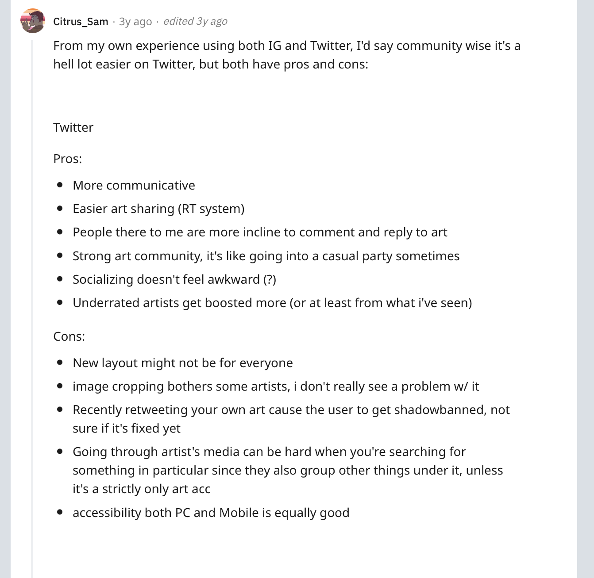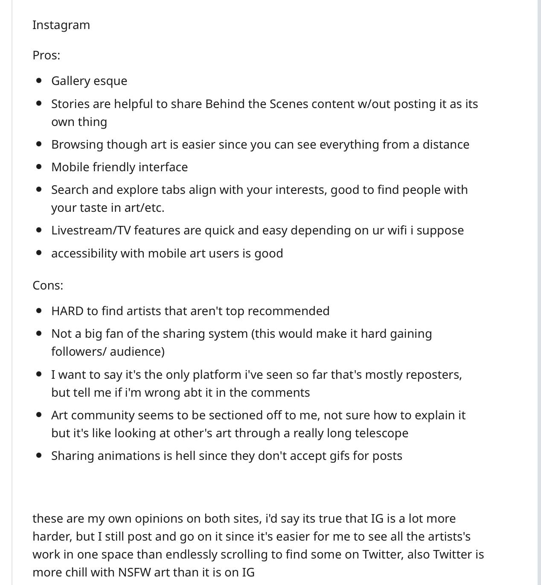

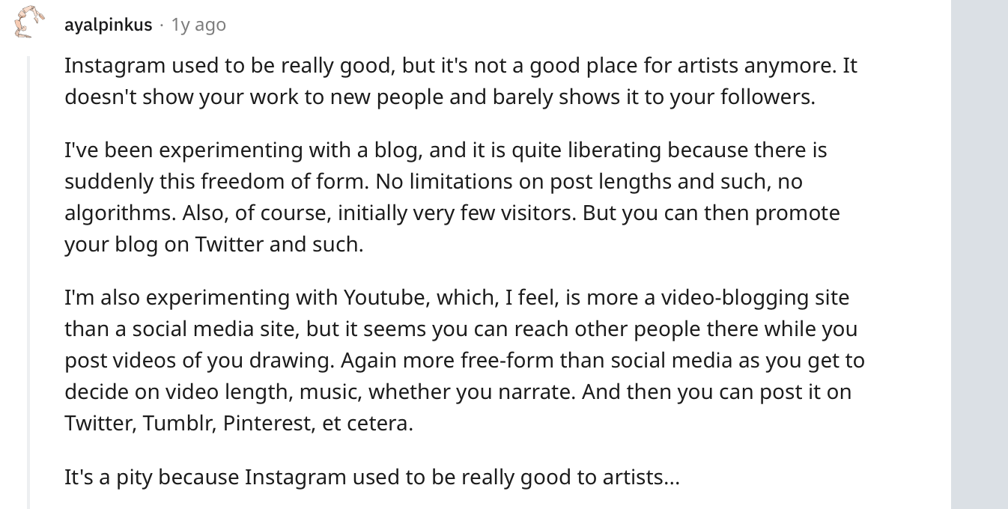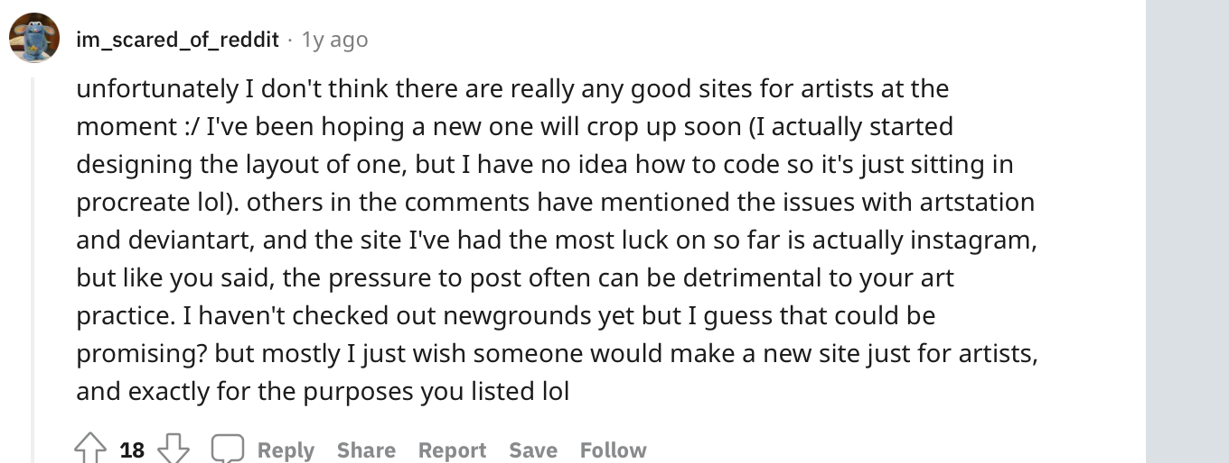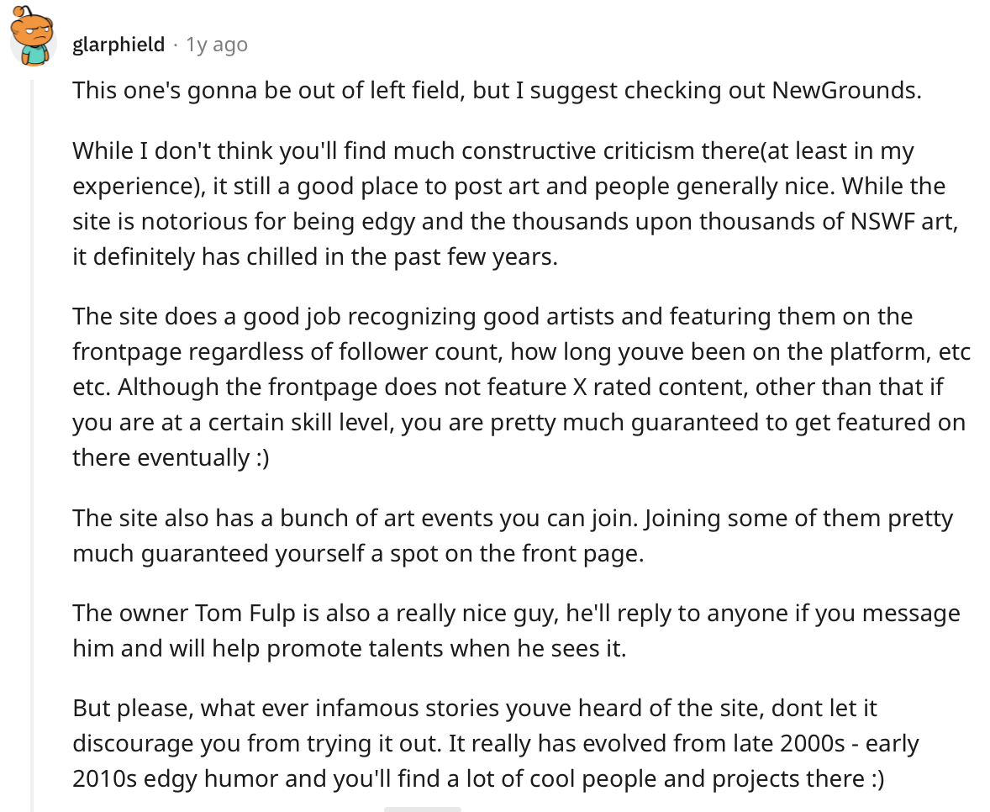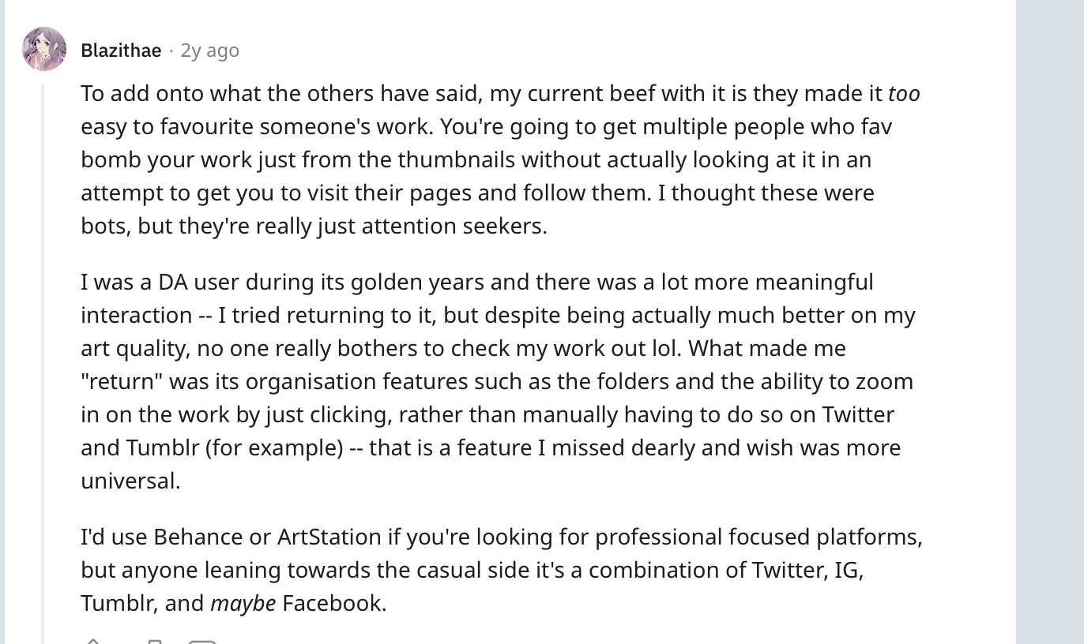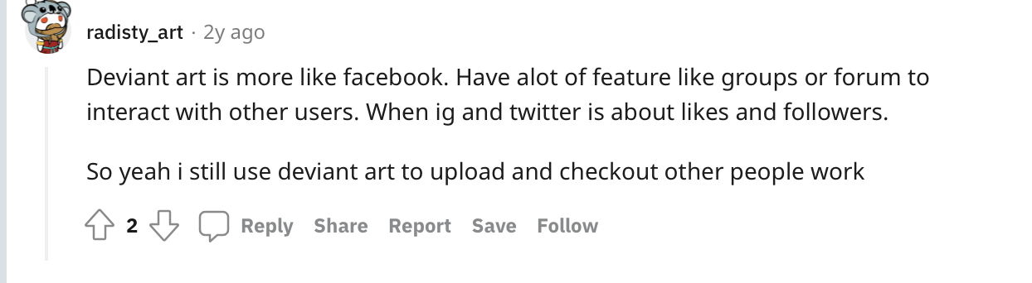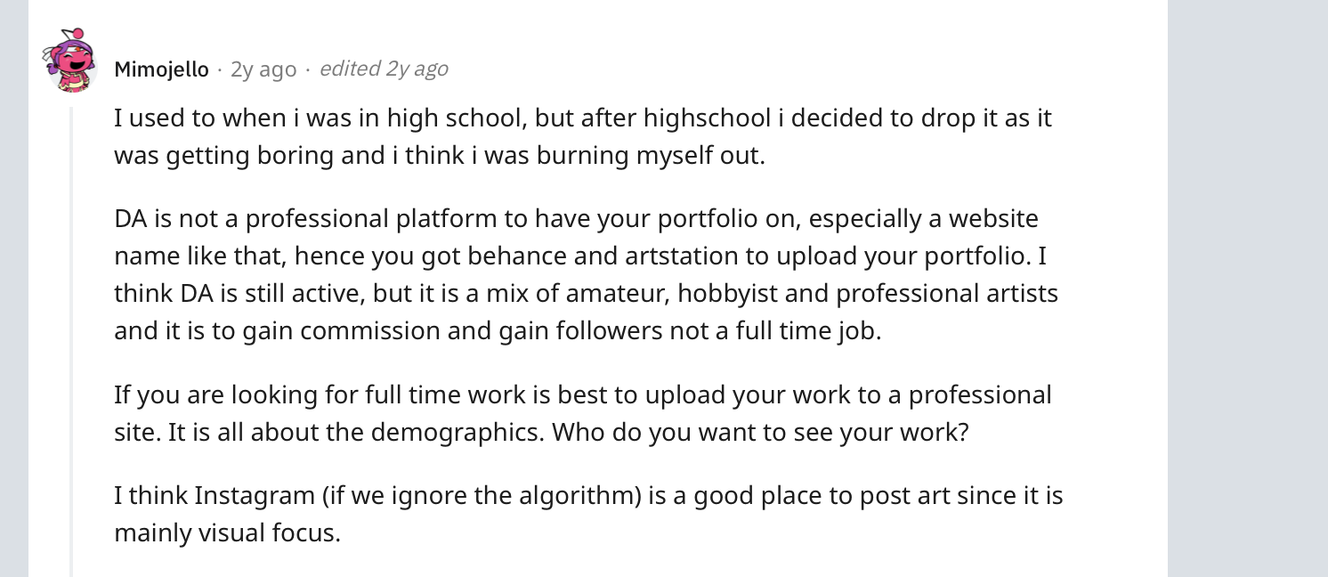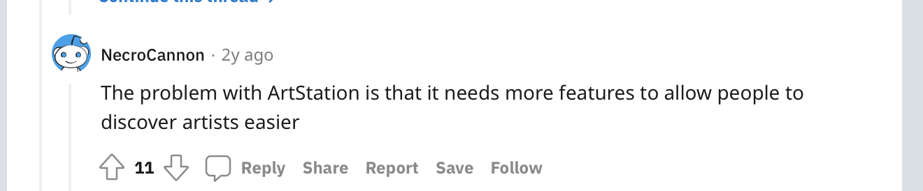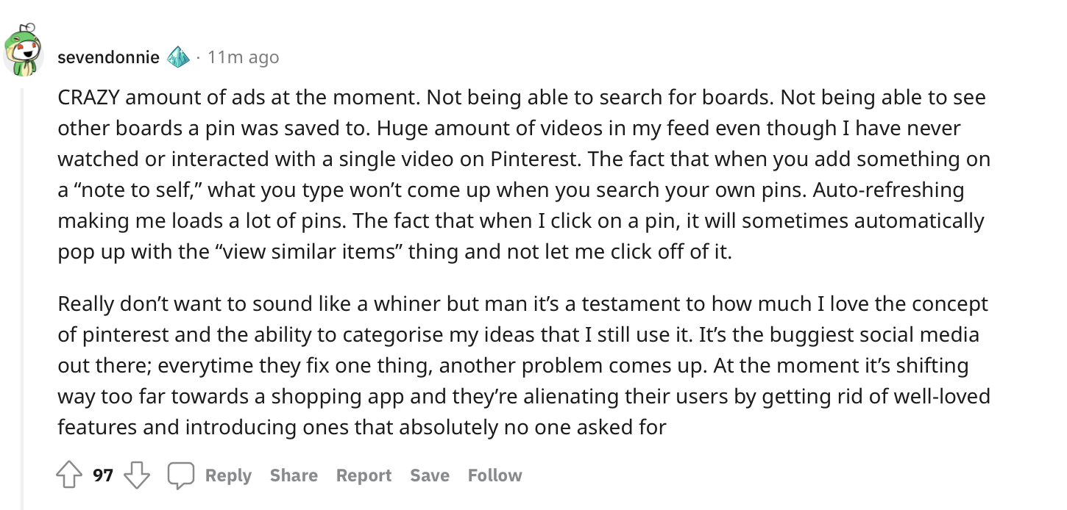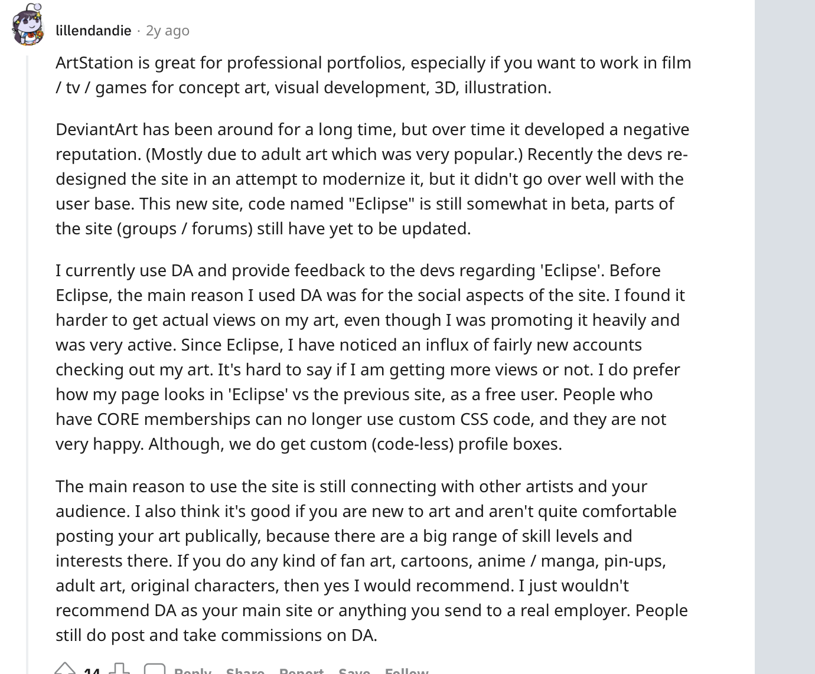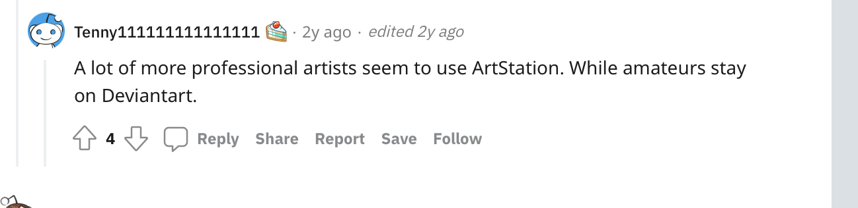

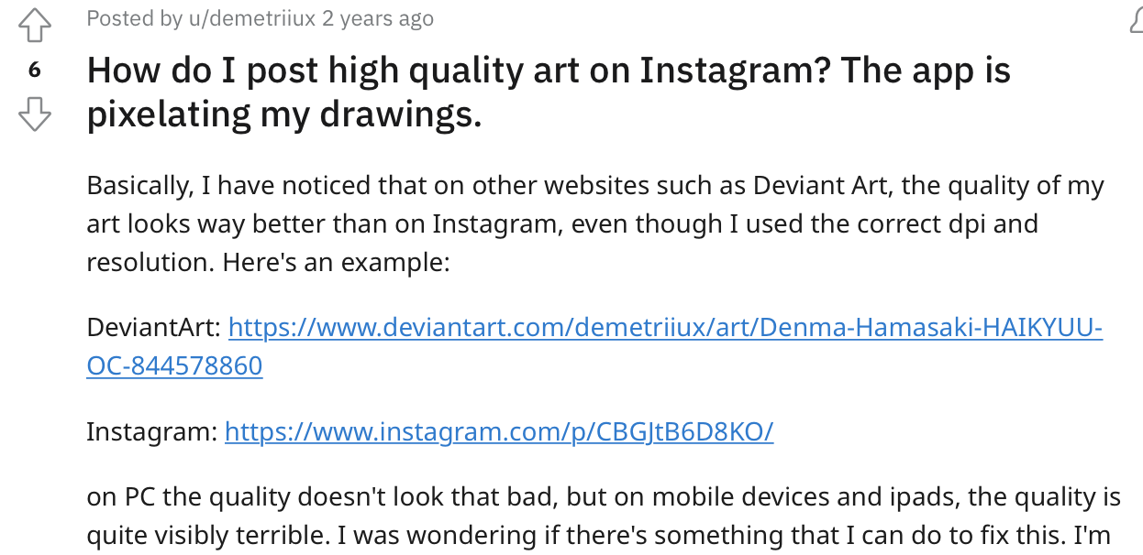

Works Cited

“r/ArtistLounge - Anyone Else Discouraged by Posting Art on Social Media ?” *Reddit*, www.reddit.com/r/ArtistLounge/comments/qqpkzv/anyone_else_discouraged_by_posting_art_on_social/.

“r/ArtistLounge - ArtStation or DeviantArt?” *Reddit*, www.reddit.com/r/ArtistLounge/comments/l9sobu/artstation_or_deviantart/.

“r/ArtistLounge - Do People Still Use DeviantArt?” *Reddit*, www.reddit.com/r/ArtistLounge/comments/iog91i/do_people_still_use_deviantart/.

“r/ArtistLounge - Where Is Your Favorite Place to Post Art Online?” *Reddit*, www.reddit.com/r/ArtistLounge/comments/j6c7d5/where_is_your_favorite_place_to_post_art_online/.

“r/Unpopularopinion - Instagram Is Ruining Everything (a Rant).” *Reddit*, www.reddit.com/r/unpopularopinion/comments/bgsmm0/instagram_is_ruining_everything_a_rant/.